The Battle of Barnet (April 14th 1471) - A brief survey
The Battle of Barnet was one of the most important battles of the Wars of the Roses. It happened for a number of reasons and had significant consequences.
The background
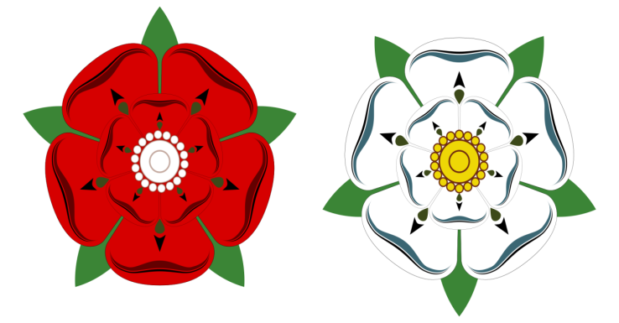
The Wars of the Roses is a term used to describe the various battles and skirmishes fought between 1455 and 1485. The red rose represents the House of Lancaster and the white rose is the symbol of the House of York.
The battles were fought to decide who should have the most influence in running the country, and later who should be the king. The two sides were led by powerful lords and nobles who sometimes changed sides, if it was in their own interest to do so.
One of the main reasons for the wars can be traced back to a very powerful king, King Edward III, who reigned from 1327 to 1377. He had five surviving sons and they had a lot of children.
Henry VI and Edward IV were descended from two of these sons and most of the English nobles were related to one of the sons as well. This made the royal family (the Plantagenets) very large and complicated and led to power struggles. Most of the leaders in the Wars of the Roses were related to each other, some were close cousins and many of them were married to members of each other’s families, (sometimes they were called the Cousins’ wars). The rivalries could be kept under control if the king was strong and determined. However, King Henry VI was a weak king and this led to open warfare.

A map to show the most significant battles of the Wars of the Roses.
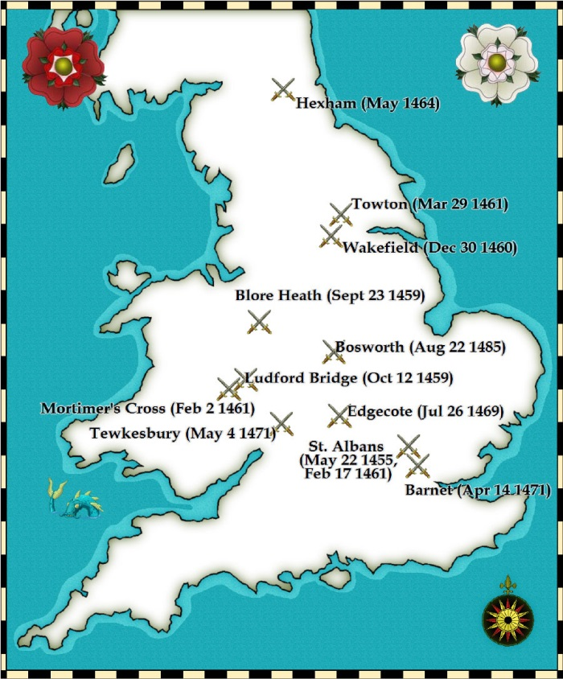
King Henry VI (1421-1461, then briefly back on the throne 1470-71) 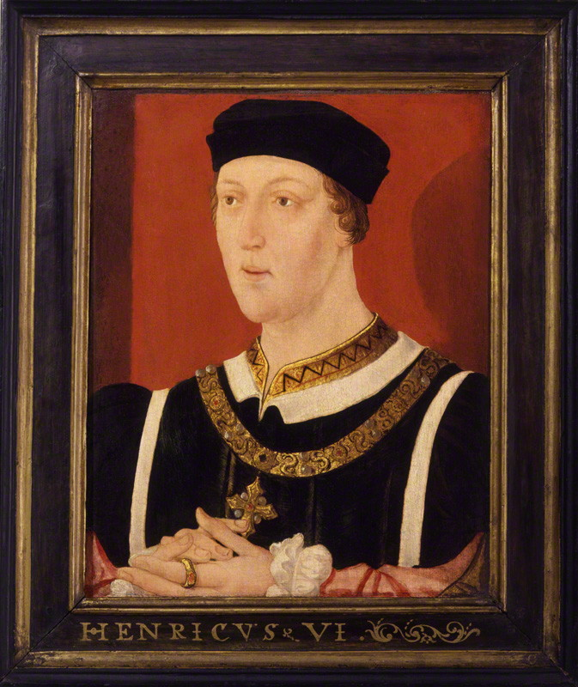
King Henry VI was the son of the popular King Henry V, who was a great warrior. Henry was only 9 months old when his father died in 1421, so at first, he could not rule as king. Other lords and nobles ruled for him and became very powerful. When Henry became old enough to rule, these nobles didn’t want to give up their power. They wanted to make sure they had most influence over the King and started to argue and fight amongst themselves. The most important of these lords included the Duke of York and his son, Edward (who became King Edward IV), and Richard Neville, Earl of Salisbury with his son the Earl of Warwick (who later became known as the Kingmaker). When Henry was older and married a French noblewoman called Margaret of Anjou, she joined in the struggle to help her husband and to try and save the throne for her son Prince Edward.
Henry VI’s wife, Margaret of Anjou
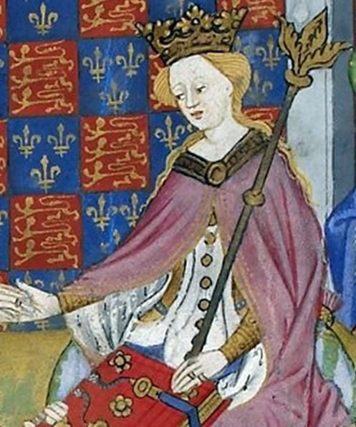

King Henry VI did not have the right personality for a medieval king. He was clever and very religious (some people thought he was a saint), but he did not understand the realities of medieval society. He did not dress like a king and he hated war and fighting. His father had won great victories in France but Henry VI was not interested and made disastrous military decisions so that England lost most of its lands in France. This made Henry very unpopular, especially with the lords and nobles who lost power, land and wealth.
Furthermore, Henry suffered from an illness which affected his judgement and made him quite delicate, leading to a breakdown lasting for 16 months. He was not able to rule during that time and never really recovered.
The Duke of York was a very ambitious and powerful lord. He had been plotting against Henry VI for a long time and there had been open warfare and battles since 1455. Henry VI struggled on until 1461 when there was a very fierce and bloody battle at Towton in Yorkshire. The Lancastrian army was defeated by the Yorkists. Henry VI was taken prisoner and the Duke of York’s son became King Edward IV. There was now a Yorkist king.
King Edward IV was the complete opposite of King Henry VI and had a lot of advantages. Edward looked like a strong king. His height (6ft 4in at a time when most men were only about 5ft 4in) meant that he could physically dominate others. He was handsome and well dressed. He was also a very good soldier and well respected for his victories.
At first everything went well for Edward. He kept Henry in the Tower of London and started to rule the country. His main supporter was the Earl of Warwick who was very powerful and the richest man in England.
A Portrait of King Edward VI
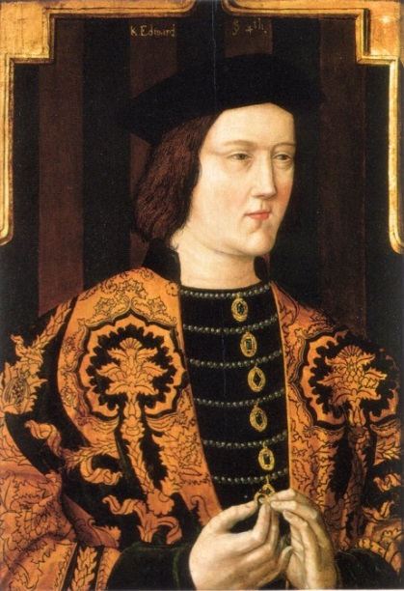
However, rich and powerful men often disagree. Warwick expected Edward to take his advice but Edward wanted to make his own decisions. In 1464 Warwick decided that Edward should marry a French princess. While Warwick was making arrangements for this, Edward suddenly married Elizabeth Woodville, (“The most beautiful woman in England,” so it was said).
A Portrait of Elizabeth Woodville
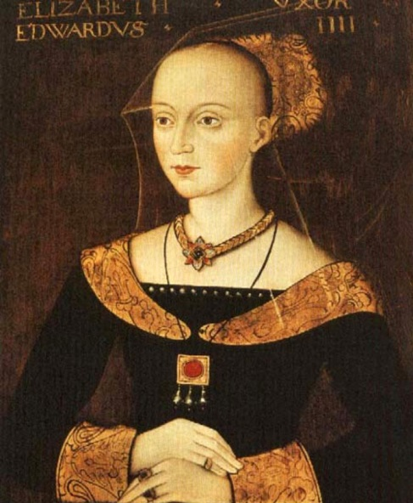
Warwick wasn’t even told about the marriage until it happened and was furious because it made him look foolish and unimportant. This was very embarrassing for Warwick but the situation was made worse because Elizabeth had a huge family of relations. Edward gave them lots of land and power and arranged for them to marry into the most influential families in England. Warwick became increasingly upset. He started to encourage powerful people to rebel against Edward. Some of the nobles resented the rise of the Woodville family and there were complaints about Edward’s rule, particularly about high taxes. At one point Warwick captured Edward and imprisoned him but was forced to let him go.
Events leading up to the Battle of Barnet
In March 1470 Warwick’s supporters were defeated in battle and he fled to France. Now, his only way to get back to a position of power was to change sides. He decided to make an alliance with Henry’s wife, Margaret of Anjou. They hated each other and were bitter enemies but she needed help and money so she agreed because she wanted her son, Prince Edward to be the next king.
Warwick was now on the Lancastrian side. He came back to England and built up an army. Edward marched to meet him but Warwick’s army was too strong. Edward fled to Burgundy, in France.
The Earl of Warwick took Henry VI out of the Tower and made him king again on October 3rd 1470. Warwick himself took all the important posts and was really the ruler of the country. However, there was trouble coming for him. Edward was given help by the Duke of Burgundy and returned to England with an army. He landed in Yorkshire in March 1471. Warwick was not prepared to fight yet so he retired to his castle in Coventry. Edward marched into London largely unopposed and took King Henry VI prisoner. Edward was King again.

The Battle of Barnet
By this time Warwick had gathered more soldiers and started to march from Coventry towards London. On April 13th he reached Barnet, stopping on high ground at Hadley Green, where he set up camp. King Edward, knowing that Warwick was on his way, took Henry VI out of the tower on the same day and marched with him out of London up the Great North Road.
(In the fifteenth century, Barnet was a village where there was an important market as well as inns, taverns and other facilities to cater for travellers. There were brewers, bakers, butchers, tanners, shoemakers and smiths. )
It was dark when Edward arrived at Barnet and his army mistakenly made camp nearer to Warwick than he intended. This turned out well for Edward because Warwick’s men fired cannon all night but the shots went too far so they did no damage.
The next morning was Easter Day. About 5 a.m. Edward’s army started to return fire with artillery and arrows. Neither side could see very much because there was a thick blanket of fog covering everything. This caused great confusion.

The two armies
It is important to note that at the Battle of Barnet there were three kings.
The past king, King Henry VI,
The present king, King Edward IV,
The future king, King Richard III (1483-85)
The leaders on the Yorkist side were:
King Edward VI; Richard, Duke of Gloucester (Edward’s 18 year old brother); and Lord Hastings
The leaders on the Lancastrian side were:
The Earl of Warwick (later called the Kingmaker); Warwick’s brother, Lord Montagu; The Earl of Oxford; and The Duke of Exeter.
The two sides lined up in the traditional way with three groups facing each other. Each had a commander with a banner with his coat of arms on it. Some soldiers had tunics with the badge on as well (Livery). This helped fighting men to identify who they were their friends and enemies in the chaos and confusion of the battle.
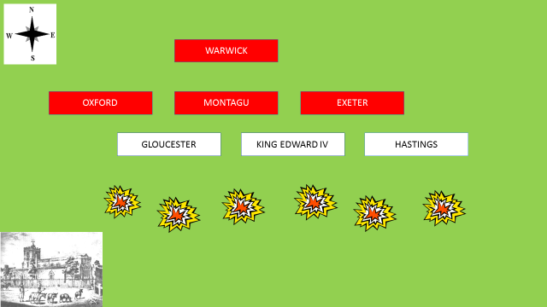
In the fog, neither side realised that they were not lined up opposite each other.

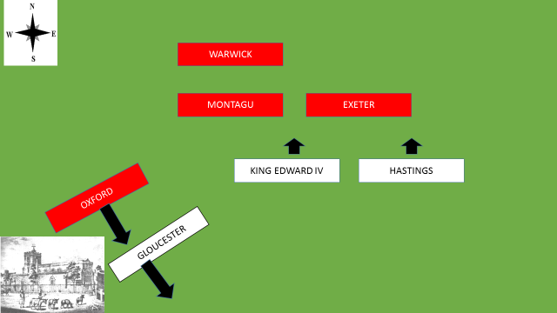
Oxford’s men charged at Gloucester’s men and overwhelmed them, chasing them into Barnet.

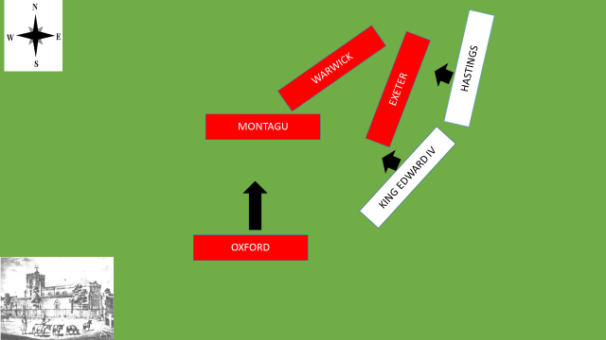.
Meanwhile on the battlefield, Hastings did the same at the other end of the line. He pushed Exeter’s men backwards. This caused the lines to move round as in the diagram.
Oxford’s men regrouped and he led them back into the battle. They didn’t know was that the fighting had moved round. They couldn’t see properly because of the fog and started attacking Montagu’s troops, mistaking them for Yorkists. Montagu’s archers fired back and Oxford’s men fled, thinking that they had been betrayed by their own side. The Lancastrians were now really demoralised and were in disarray. From a winning position, the Lancastrians were now losing.
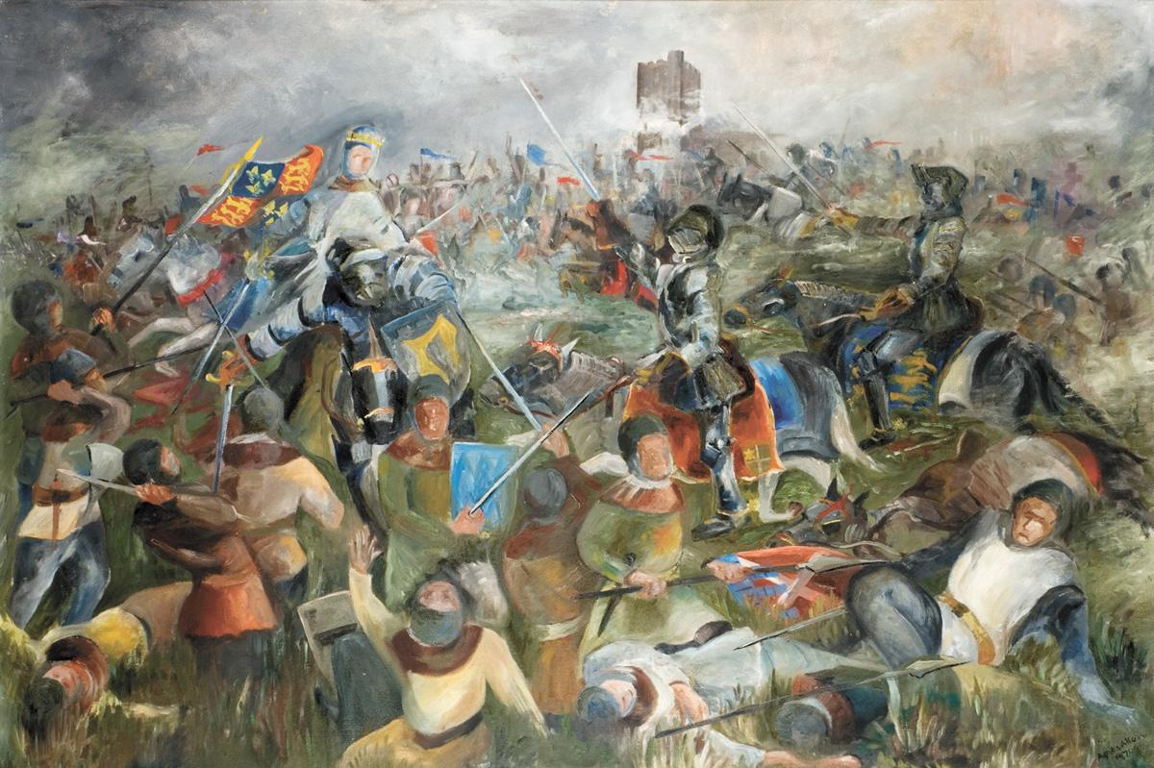
An Artist’s impression of the battle in the fog

Edward brought up fresh soldiers and the fighting continued. Montagu was killed and Exeter wounded. Warwick tried to keep the battle going but it was no good. Many of the Lancastrian soldiers were killed or they ran away. Warwick tried to get back to his horse but was killed before he reached it. The Lancastrian leader was dead and the battle was over. It had lasted about three or four hours. It is thought that between 1500 and 4000 men died. A writer at the time wrote, “It is said that there has been no fiercer battle in England the last 100 years”.
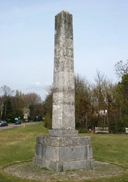
This is the memorial to the Battle of Barnet at Hadley Highstone. “Here was fought the famous battle between Edward IV and the Earl of Warwick April 14th Anno 1471 in which the Earl was defeated and slain”
King Edward IV announced his victory in London. He needed to be certain that everyone believed that the Lancastrians were really defeated and that there would be no rumours that Warwick had escaped to fight again. Therefore, Warwick’s dead body was stripped naked and put on display in a wooden coffin in St Paul’s Cathedral. King Henry was put back into the Tower.
King Edward was safe for the moment, but this wasn’t quite the end because Henry VI was still alive and there was going to be trouble from Henry’s wife Margaret and their son, Prince Edward. They had been in France and had tried to get back to help Warwick but the weather had been too bad for them to set sail. If they had arrived in time to help Warwick there might have been a different result.
Some images of what battles were like in the fifteenth century.
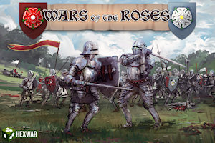
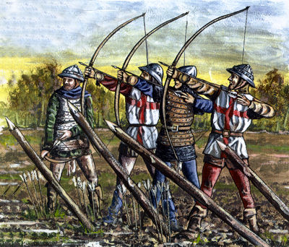
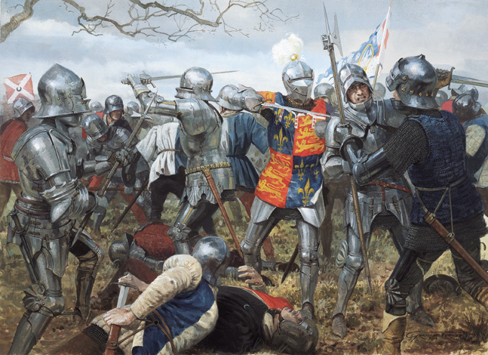
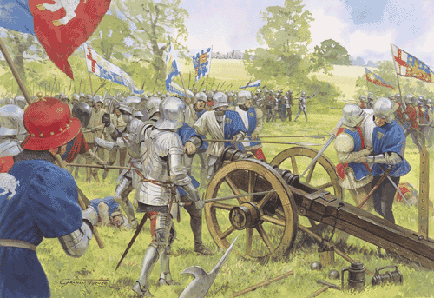

What happened after the battle of Barnet
Margaret and her son finally arrived in England They had raised an army and were determined that Henry’s son Prince Edward should be the next king. King Edward IV marched to stop them. The two armies met at Tewkesbury in May. This battle proved to be the end for the Lancastrians. Prince Edward was killed. Margaret was captured and imprisoned. Soon afterwards King Henry died in the Tower. His murder was probably ordered by Edward, as he had no use for Henry any longer.
King Edward IV now ruled for twelve years with very little trouble.
The very end of the Wars of the Roses
King Edward died in 1483. His twelve year old son became King Edward V. However, it is always a problem when a child becomes king. King Edward IV’s brother, Richard of Gloucester took over with the title Protector of the Realm. Very soon, Edward V and his brother mysteriously disappeared and were never seen again. No one knows what happened to them, but it is almost certain they were murdered. They are often called the Princes in the Tower. Richard made himself King Richard III, but he did not last long.
A portrait of King Richard the third
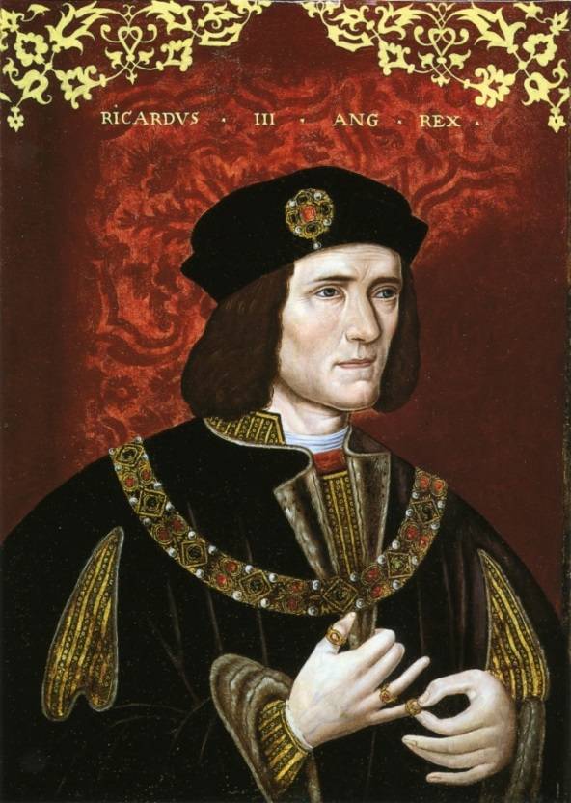
In 1485, a distant relative also related to King Edward III, challenged Richard. His name was Henry Tudor. The two armies met at Bosworth Field in August 1485. Richard fought very bravely but was defeated. According to legend, his bloody crown fell into a thorn bush. It was taken to Henry Tudor who was crowned King Henry VII. This was the start of the Tudor dynasty.
King Henry VII brought the Lancastrians and Yorkists together. He married King Edward IV’s daughter Elizabeth and he put the red and white roses together to make the Tudor rose.
